**Application**

**Installation and Deployment Guide**

Table of Contents

Environment prerequisite 2

Step 1 - Clone the project 2

Step 2 – Build the project 2

Step 3 – Run the project 3

External configuration 4

# Environment prerequisite

* Java environment.
* Maven (installation for maven at: <https://maven.apache.org/install.html> )
* MySQL database (attached document)

# Step 1 - Clone the project

Clone the project from Github at url: <https://github.com/KN193/GroupB_FinalProject> using either git clone or download as zip file.

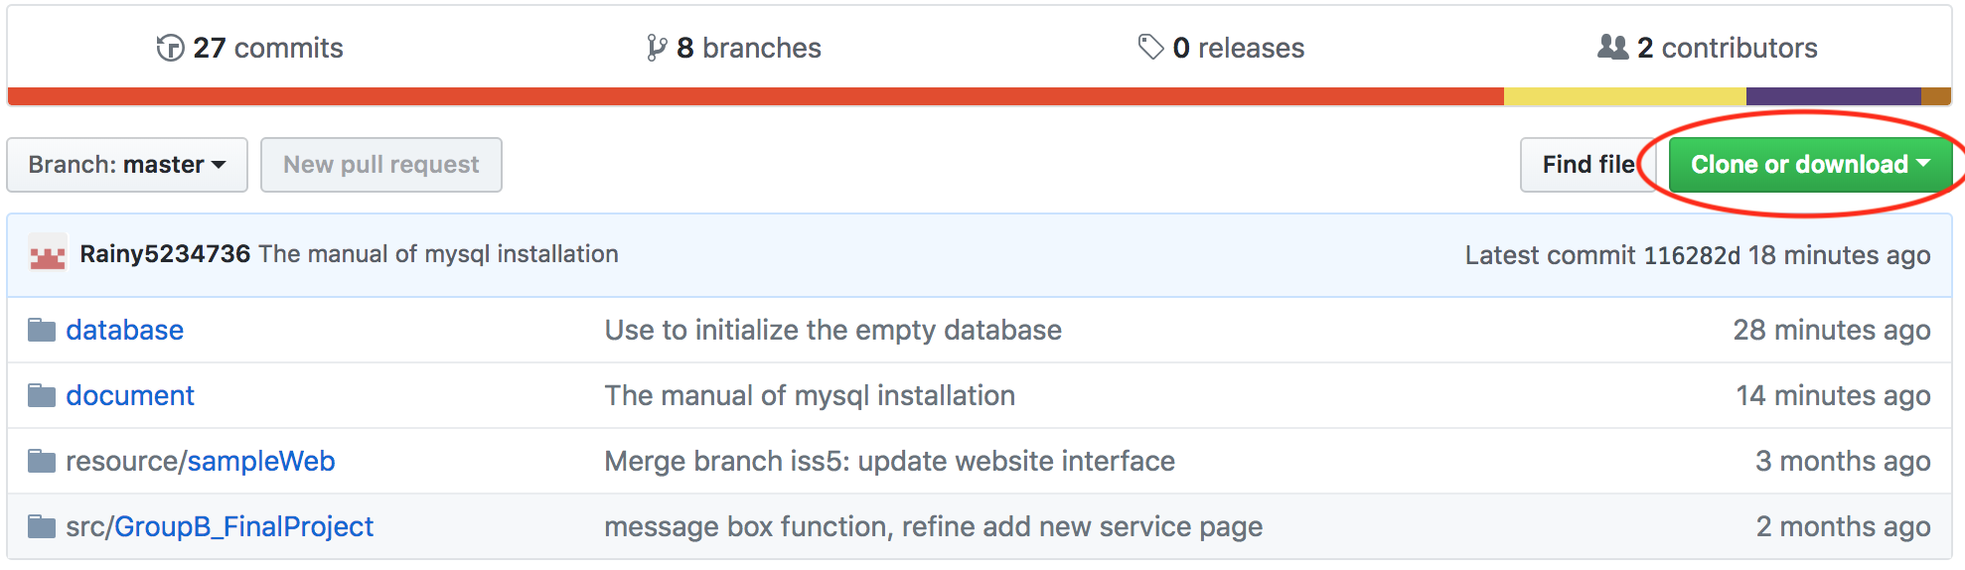

# Step 2 – Build the project

Navigate to /GroupB_FinalProject/src/GroupB_FinalProject/

Start terminal (for MacOS) or command-line (for Windows) at above directory.

Input command “*mvn clean install*” to build the project.

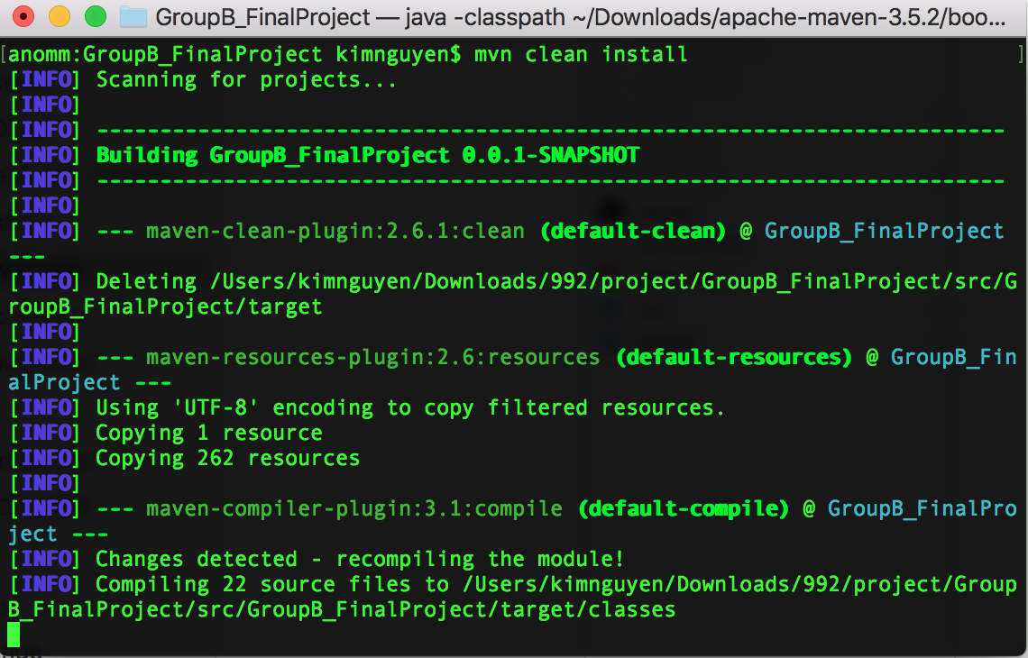

Built project with generate folder named “target”. “target” folder contain a fat jar file for running this project.

# Step 3 – Run the project

At “target” folder, start the terminal/command-line and input following: ***java -jar GroupB_FinalProject-0.0.1-SNAPSHOT.jar*** to run the project. Below screen shows a project run successfully.

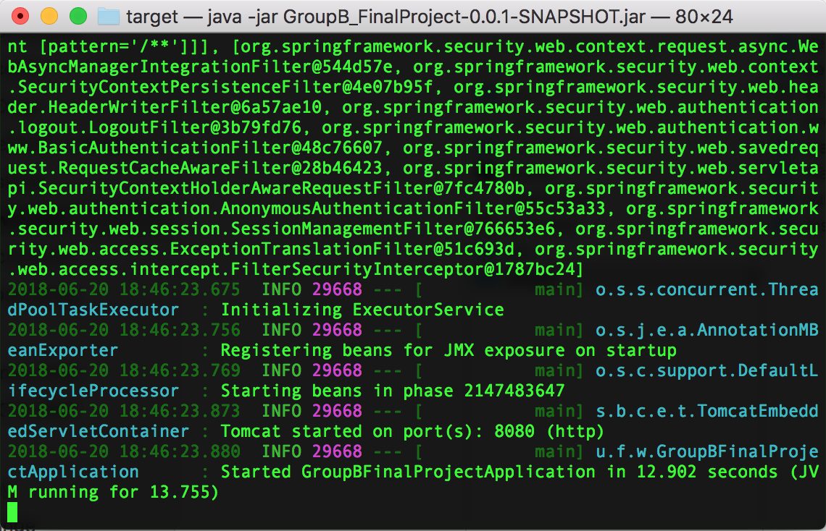

## External configuration

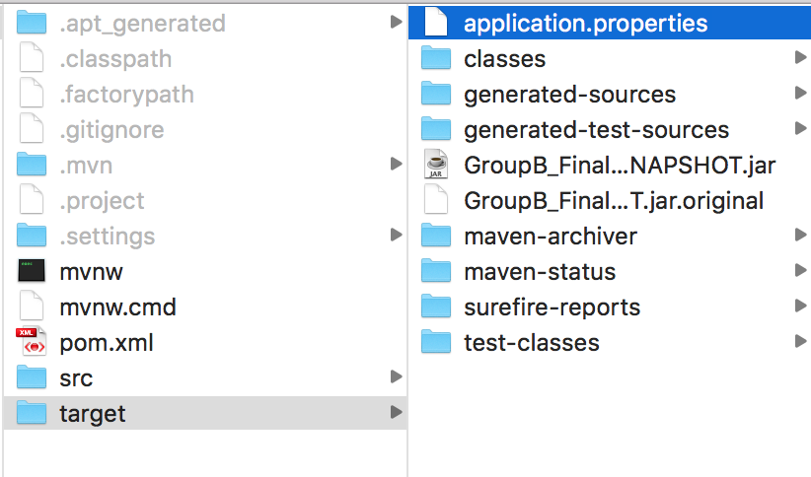

In some circumstances, we might need to config number of variables due to the varying of environment. For Spring Boot, we can create a new configuration file (e.g: I used application.properties) to config the system. Put this file in the same location with the jar file and input following command ***java -jar GroupB_FinalProject-0.0.1-SNAPSHOT.jar --spring.config.location=file:./application.properties***

The following is the content of application.properties file.

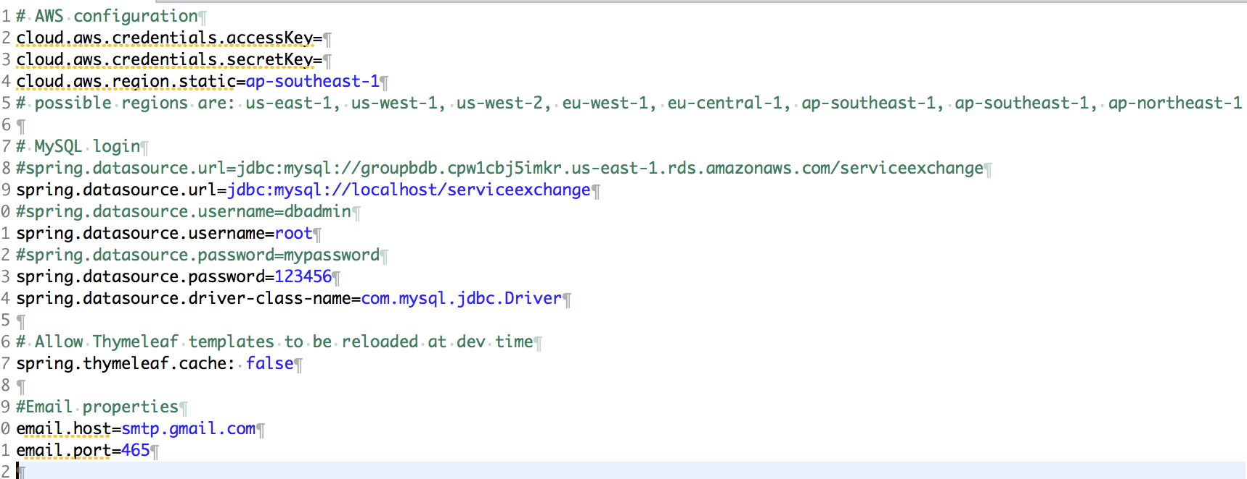

Go to your browser, navigate to url **localhost:8080** to access the application. Successful started up website should be:

